**Quarterly Report – Public Page**

**Date of Report:** *10th Quarterly Report, March 28, 2025*

**Contract Number:** *693JK32210001POTA*

**Prepared for:** *Government Agency: DOT and Co-funders*

**Project Title:** *Developing Corrosion Control Monitoring Technology for Hazardous Liquid Breakout Tanks*

**Prepared by:** *Pipeline Research Council International, Inc.*

**Contact Information:**  *Janie Norton,* [*jnorton@prci.org*](mailto:jnorton@prci.org) *703-205-1600 ext: 105*

**For quarterly period ending:** *March 31, 2025*

**1: Items Completed During this Quarterly Period:**

|  |  |  |  |  |  |
| --- | --- | --- | --- | --- | --- |
| ***Item***  ***#*** | ***Task***  ***#*** | ***Activity/Deliverable*** | ***Title*** | ***Federal Cost*** | ***Cost Share*** |
| 21 | 2 | Analyze various monitoring data to determine the direct and indirect corrosion rates and compare those to the tank bottom indications, and regulatory requirements | Results to be included in the quarterly report | $9,121 | $9,121 |
| 22 | 4 | Analysis of the laboratory scale experimental data, and the control experiments data | Results to be included in the quarterly report | $3,258 | $3,258 |
| 23 | 2 | Analysis of the monitoring data to determine the inspection intervals | Results to be included in the quarterly report | $3,258 | $3,258 |
| 24 | 5 | Quarterly Project Management & Status Update Reporting | Submit 10th quarterly report | $4,477 | $4,477 |

**2: Items Not Completed During this Quarterly Period:**

|  |  |  |  |  |  |
| --- | --- | --- | --- | --- | --- |
| ***Item***  ***#*** | ***Task***  ***#*** | ***Activity/Deliverable*** | ***Title*** | ***Federal Cost*** | ***Cost Share*** |
|  |  | None |  |  |  |

**3: Project Financial Tracking During this Quarterly Period:**

Note that this chart reflects Federal share only.

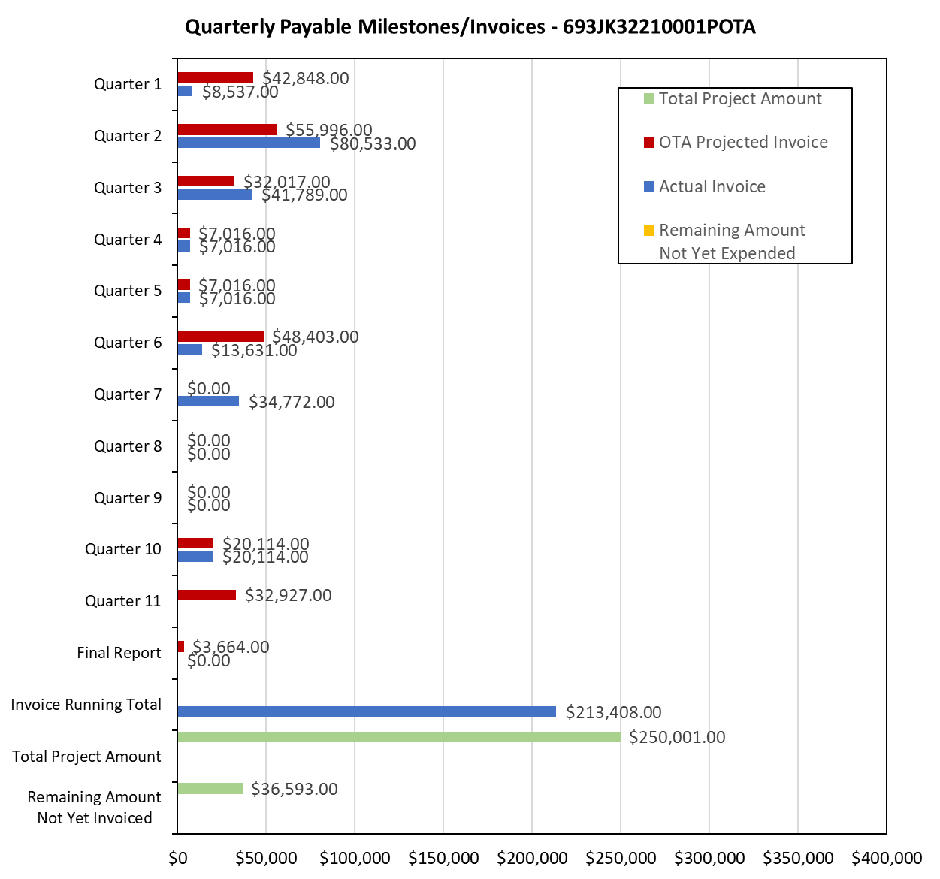

**4: Project Technical Status:**

**Item 21, Task 2  Analyze various monitoring data to determine the direct and indirect corrosion rates and compare those to the tank bottom indications, and regulatory requirements.** Results to be included in the quarterly report: The coupon monitoring data and soil-side corrosion indication data was analyzed for several tanks. An example tank data is listed in Table 1.

|  |  |  |  |  |  |  |  |  |  |  |  |  |
| --- | --- | --- | --- | --- | --- | --- | --- | --- | --- | --- | --- | --- |
| **Table1. Comparison of laboratory and field mass-loss coupons with tank bottom plate surface scan data for a representative tank** | | | | | | | | | | | | |
| **Sample ID** | **Laboratory**  **Coupon** | | **Field Coupon** | | | | **UT coupon CR (mpy)** | **Floor Scan Results for Plate Above Sand Sampling Locations and Mass-Loss Coupons Locations** | | | **2019 CP Data** | |
| **SA CR\***  **(mpy)** | **DP**  **CR\*\***  **(mpy)** | **Surface Average Corrosion Rate (mpy)** | | **Deepest Pit Corrosion Rate**  **(mpy)** | | **Plate #** | **Anomalies**  **Remaining Thickness (inch)** | **CR**  **(mpy)** | **B**  **On/off**  **(V)** | **U**  **(V)** |
| **U\*\*\*** | **B\*\*\*\*** | **U** | **B** |
| **East** | 0.92 ± 0.34 | 12.2 ± 1.3 | 0.41 | 0.09 | 8.8 | 5.3 | − | 13-11 | 1 × 0.200  2 × 0.205 | 5.6  5.0 | -0.922/ -0.655 | -0.001 |
| **West** | 0.28 ± 0.06 | 1.9 ± 0.5 | 8.44 | 11.42 | 39.5 | 36.8 | − | 11-1  11-2 | 1 × 0.180  2 × 0.200 | 7.8  5.6 | -1.424/ -0.425 | -0.389 |
| **North** | 1.50 ± 0.57 | 18.5 ± 18 | 6.32 | 8.74 | 41.7 | 45.9 | − | 1-8  1-11 | 2 × 0.180  1 × 0.190  1 × 0.205 | 7.8  6.7  5.0 | -0.677/ -0.004 | -0.151 |
| **South** | 0.36 | 13.5 | 28.39 | 9.76 | 191.7 | 52.7 | 1.43  6.4 | 23-5 | 1 × 0.160  2 × 0.200  2 × 0.205 | 10.0  5.6  5.0 | -1.463/ -0.006 | -0.056 |
| *SACR = surface average corrosion rate, **DPCR = Deepest pit corrosion rate, ***U=Unbonded, ****B=Bonded | | | | | | | | | | | | |

Based on the analysis of the six tanks, following points are made:

* Laboratory coupons appear to corrode less than the field coupons. This may be partly due to the temperature of the coupons. The field coupons could be at higher temperature (30-40 °C) than the laboratory coupons which were under the laboratory ambient conditions of approximately 22 °C.
* Bonded field coupons did not necessarily under corrode compared to the unbonded field coupons. This suggests that use of either bonded or unbonded field coupons is acceptable. It is however mentioned that use of the bonded field coupons is likely to remove any doubt on validity of the data derived from the unbonded coupons. This also indicated that compliance with NACE CP criterion of 100 mV for the coupons does not necessarily results in less corrosion.
* An analysis of the tank bottom indications and field coupons corrosion rate indicated that field coupons generally provide level of information that commensurate with the tank bottom anomaly corrosion rates.

This item has been completed. This item links to items 9(a), 9(b), 9(d) in Attachment 1 Team Project Activities. This item also links to item 9 in Attachment 2 Project Deliverables.

**Item 22, Task 4  Analysis of the laboratory scale experimental data, and the control experiments data.** Results to be included in the quarterly report: The laboratory-scale experiments were conducted to understand the VCI injection intervals and VCI migration in cone-up configuration.

Regarding the VCI reinjection, two separate experiments were conducted. Corrosive conditions were created by adding salts to the filed sand samples such that the chloride concentration is approximately 130 ppm. ER probes were used for the corrosion monitoring. The ER probe corrosion rate data for the two experiments is listed in Table 2.

|  |  |  |  |  |  |  |
| --- | --- | --- | --- | --- | --- | --- |
| **Table 2. Laboratory Scale Experiment Data to Study VCI Reinjection Interval** | | | | | | |
| **Experiment #** | **Pre-VCI**  **Corrosion Rate**  **(mpy)** | | **During VCI**  **Corrosion Rate**  **(mpy)** | | **Corrosion Rate After Allowing for VCI Escape (mpy)** | |
| **Probe 1** | **Probe 2** | **Probe 1** | **Probe 2** | **Probe 1** | **Probe 2** |
| 1 | 4 | 4.5 | 0 | 2 | 0.2 | 0.5 |
| 2 | 6 | 6 | 0 | - | 9 | - |

The Experiment 1 data showed that VCI chemistry is durable even after allowing for escape, and therefore, no reinjection is needed. The experiment 2 data showed that the corrosion started almost immediately after allowing for the VCI escape, thus necessitating the VCI reinjection

Regarding the VCI migration in cone-up configuration, two separate experiments were conducted. Corrosive conditions were created by adding salts to the filed sand samples such that the chloride concentration is approximately 130 ppm. ER probes were used for the corrosion monitoring. The ER probe corrosion rate data for the two experiments is listed in Table 3.

|  |  |  |  |  |
| --- | --- | --- | --- | --- |
| **Table 3. Laboratory Scale Experiment to Study VCI Migration in Cone-Up Tank Bottom Configuration** | | | | |
| **Experiment #** | **Pre-VCI**  **Corrosion Rate**  **(mpy)** | | **During VCI**  **Corrosion Rate**  **(mpy)** | |
| **Probe 1** | **Probe 2** | **Probe 1** | **Probe 2** |
| 3 | 6 | 2 | 0 | 1 |
| 4 | 2 | 2 | 0 | 0 |

The Experiments 3 and 4 data showed that timeframe for the VCI effectiveness was same as when the experiments were set flat, indicating that VCI migration is equally effective in the cone-up configurations. It is however noted that scale of these experiments is limited to the laboratory conditions.

Two controlled large-scale experiments were conducted to understand the VCI migration and dispersion range. Corrosive sand conditions were established, and mass-loss coupons were allowed to corrode under the corrosive sand conditions. VCIs were injected and additional coupons were added at the time of VCI injection. Representative corrosion rate data from the two large-scale experiments is listed in Table 4.

| **Table 4. Large-Scale Experiment Coupon Corrosion Rate Data** | | | | |
| --- | --- | --- | --- | --- |
| **Coupon Location from VCI Injection Point (ft)** | **VCI-A Large Scale Experiment Coupon Corrosion Rate**  **(mpy)** | | **VCI-B Large-Scale Coupon Corrosion Rate**  **(mpy)** | |
| **Pre-VCI**  **Coupon** | **Post-VCI Coupon** | **Pre-VCI**  **Coupon** | **Post-VCI Coupon** |
| 5 |  |  | 6 | 0.5 |
| 10 | 7 | 3.3 | 10 | 4.5 |
| 15 | 4.3 | 0.6 | 10 | 3.4 |
| 20 | 4.7 | 2.9 | 8 | 4.3 |
| 25 | 3.9 | 0.9 | 6 | 5.5 |
| 30 | 6.7 | 1.4 | 9 | 6 |
| 35 | 5.0 | 0.7 |  |  |
| 40 | 3.4 | 0.4 |  |  |
| 45 | 5.7 | 0.7 |  |  |
| 50 | 7.7 | 4.6 |  |  |

Based on the data listed in Table 3, dispersion rage for VCI-A is approximately 40 ft and for VCI-B is 15-20 ft. It is noted that the VCI dispersion rage is depended upon the VCI dosages.

This item has been completed. This item links to items 7 and 8 in Attachment 1 Team Project Activities. This item also links to item 8 in Attachment 2 Project Deliverables.

**Item 23, Task 2  Analysis of the monitoring data to determine the inspection intervals.** Results to be included in the quarterly report: The monitoring data from three tanks were analyzed to estimate inspection interval as per API 653. The monitoring data were analyzed for three tanks: two tanks with indications of severe soil-side corrosion and one tank with minimal indication of soil-side corrosion. For the first two tanks with severe soil-side corrosion, the soil-side indications in the API 653 inspection reports had significant corrosion, and the targeted monitoring data at four locations also exhibited comparable corrosion. The tank inspection intervals were calculated using the monitoring data and were within the range of the pre-repair inspection intervals reported in API 653 reports of the respective tanks. For the third tank, the soil-side corrosion indications were not severe and the same was observed in the coupons that were placed under the tanks. For the third tank, the monitoring-based inspection intervals were also within the range of the values listed in the API 653 inspection report. The key take-away: effective monitoring provides a reasonable estimate of the inspection interval. This item links to items 9(c) and 9(e) in Attachment 1 Team Project Activities. This item also links to item 9 in Attachment 2 Project Deliverables.

**Item 24, Task 5  Quarterly Project Management & Status Update Reporting.** Submit 10th quarterly report: The 10th quarter project meeting was held on March 19, 2025. This item has been completed. This item links to items 10 and 12 in Attachment 1 Team Project Activities. This item also links to item 10 in Attachment 2 Project Deliverables.

**5: Project Schedule:**

The project is on-track as per the revised deliverable schedule.